Social Housing Stock on the Woodberry Down Estate
Interim Report

Prepared for the WDCO board by Gloria Obilana and Geoff Baron (March 2025)

Table of Contents
1: Executive Summary: Social Housing on Woodberry Down 2
2: Preface 4
3: Introduction 4
3.1 Purpose of this Report 4
3.2 Historical Background 4
4: The Partnerships 5
4.1 A Partnership with WDCO 5
4.2 The Delivery Partners Agreement 6
5: The total numbers of homes 7
5.1 Masterplans 7
5.2 The numbers of homes on the site is increasing 7
5.3 Current Projections for homes on Woodberry Down 9
5.4 Affordable Housing and Viability 9
5.5 The Question of Housing Density 10
6: Conclusions 10
6.1 More Social Homes Overall 10
6.2 Recommendations and Next Steps 11
7: References 11

1: Executive Summary: Social Housing on Woodberry Down
This report aims to clarify the current and projected numbers of homes to be built on the
Woodberry Down Estate as the regeneration programme proceeds. It highlights the proportions between homes for social rent, for shared ownership and private ownership.

It was commissioned by board members taking part on the WDCO Awayday which took place at the Edge youth centre in January 2025. It aims to provide evidence for the Board to make informed choices on the future development of the estate whilst the regeneration advances towards its later phases.

This year (2025) the latest outline planning proposal for the third Masterplan is being debated by Hackney Council. It will establish the number of homes projected to be built
in Phases 5-8 of the development. This milestone is hence an opportune moment for the WDCO Board to reflect on our present living conditions and to consider the way forward for any future construction.

It is now over 20 years since the Woodberry Down Area Action Plan (AAP) was published and adopted by Hackney Council following a public consultation. The project was agreed to be substantially self-financing as only very limited Government funding was available. The redevelopment programme therefore proceeded on the basis that profits from sales of private homes will be used to pay for any new social housing.

At the start of 2009 there were approximately 1500 homes for social rent on the estate. In the first Masterplan it was suggested that the development would provide: 4,664 homes of which approximately 34% would be for social rent (providing 1579 homes) and a further 7% would be for shared ownership

By the time of the second Masterplan (2014) there were projections for 5557 homes in total; of which 2214 (40%) would be affordable, split 50% social rent 50% shared ownership. Now, it seems that current projections (March 2025) suggest that there could be upwards of 6495 dwellings built by completion of the later phases - three times the estates original size.

One key factor influencing the increase in the total number of homes is the development’s financial viability, which relies on the sales of private homes to fund construction. Currently a ratio of 41% of affordable homes is required for the regeneration to be sustainable. An increase in homes for social rent will necessitate higher housing density in later phases, or some other form of subsidy. It isnt as simple as reducing the proportion of homes for shared ownership and making them socil rent. The split of roughly 40% affordable and 60% private seems fixed in the present financial circumstances.

In the latest Affordable Housing statement (Oct. 2024) the present building targets are;

Private | Intermediate | Social Rent
Target: 57% | Target: 24.1% | Target: 18.9%
Range: 55-65% | Range: 21.3-27.1% | Range: 14.6-20.4%

These targets possibly present WDCO with some room for discussions with the Delivery Partners. It should be noted that so far, the figure of 41% social homes on the estate has been achieved as the original agreement demanded and it also seems likely to be met in future phases. There is no evidence that any eligible household identified under the original 2007 redevelopment plans can’t be provided with a new property.

In conclusion, the overall density of homes and the viability of the regeneration are now the overriding factors in determining the numbers of social homes that can be built.

We therefore would urgently like the Board’s consent to seek a meeting with the Delivery Partners to initiate a discussion on this matter. This is to take place independently of the Round Table.

We recommend that the Board makes time available on its agenda to deliberate policy decisions regarding:

- Increasing housing density on the estate to provide more social homes for rent.
- To investigate the flexibility of Increasing the number of homes for rent at the expense of increasing the number of private homes and at the same time reducing the number of shared shared ownership homes.
Additionally, we seek the Board’s permission from to continue our investigations into these matters.

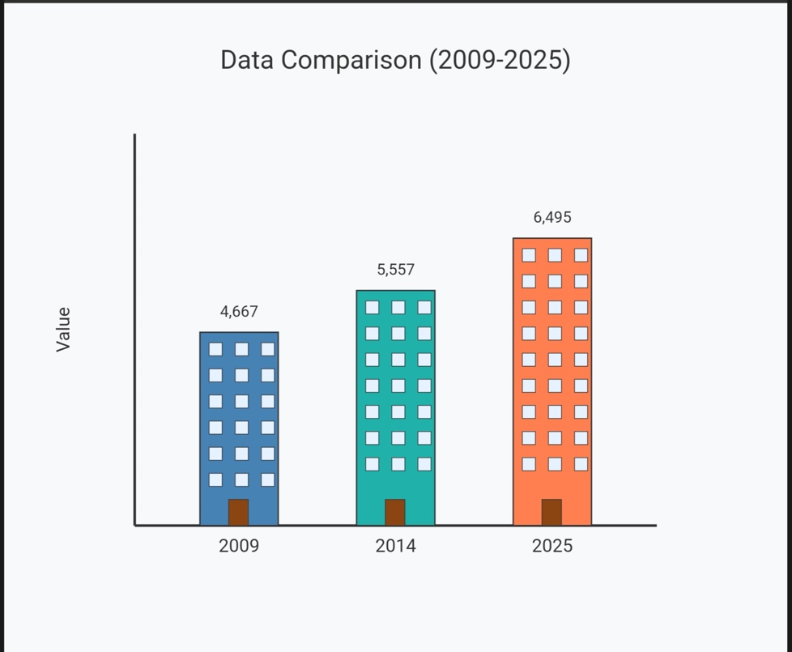

2: Preface
This report was commissioned by board members taking part on the WDCO Awayday which took place at the Edge youth centre in January 2025. It is deliberately limited in scope to avoid erring into the political sphere. It aims to provide the board with enough evidence to make informed choices on the future numbers of homes to be built as the regeneration moves into its later phases.

The information presented in this report has been based upon documents that are available either from previous board meetings or are published plans and papers available from Hackney Council.

3: Introduction

3.1 Purpose of this Report
This report aims to clarify the known and projected numbers of homes to be built on the
Woodberry Down Estate as the regeneration programme proceeds. It highlights the proportions between homes for social rent, for shared ownership and private ownership.

So far, enough construction work has taken place for the Board to assess the success of the development so far and to take a reasoned view of how it might envisage any future works to evolve. The report also demonstrates that WDCO could play a significant role in shaping the outcomes of future phases.

Some of the issues examined are:
Firstly, of the numbers of social rented homes which existed on Woodberry Down prior to the launch of the regeneration scheme, how many are to be replaced by new homes on a one-to-one basis by the end of the development phases?

Secondly, what are the main factors in determining the proportions of homes for social rent, for shared ownership and private ownership?

Lastly, what are the likely implications for increasing the number of homes built in future phases?

3.2 Historical Background

Discussions on the regeneration began back in the 1990’s after structural surveys of the properties suggested that it was too expensive to renovate the approximately 2000 homes (some of which had already been taken into private ownership under the ‘Right to Buy’ scheme) on the estate.

In 2004 the Woodberry Down Area Action Plan (AAP) was published and adopted by Hackney Council following a public consultation. This established the general principles over which the redevelopment of the area would take place. The project was agreed to be substantially self-financing as only limited Government funding was available. The redevelopment programme therefore proceeded on the basis that private investment will be used to pay for the new social affordable housing.

The original AAP would, of course, evolve over the years and each new phase of development would slowly increase the total numbers of homes built in the area. This was in part the result of changes in the political, environmental and economic circumstances from those originally conceived.

4: The Partnerships

4.1 A Partnership with WDCO

In 2018 a partnership agreement was established between WDCO and the following organisations involved in the development programme, namely; Hackney Council, Berkeley Homes, Notting Hill Genesis and Manor House Development Trust. This document established a framework to build trust between all the parties and provided for a way of working that gave the WDCO board a voice in the decision making process, however, this was within a hierarchical structure that put ‘The Round Table’ at the top.

This year (Summer 2025) the latest outline planning proposal is being debated by Hackney Council which will establish the number of homes being built in Phases 5-8 of the development. This potentially is a useful milestone for the WDCO Board to reflect on our present living conditions and consider the implications of any future building works. Do we want more houses built and hence a higher density on the estate?

There are good justifications for raising discussions about the latest proposals. Even putting aside any concerns with housing numbers, environmental considerations and transport issues, as long ago as 2014 Hackney Council suggested in a planning document that there should be discussions on the proportions of affordable homes on the estate -
‘We would require a review to be carried out during phase 5, or at a point early enough in the process to influence the dwelling mix in Phase 6 onwards, to look to increase the percentage of family housing and to address any housing tenure and dwelling-size imbalance from the earlier phases. ‘

In the updated draft partnership agreement (2024) NHG commented that the -
‘2024 Masterplan has upper and lower number ranges, and these exceed the PDA numbers for shared ownership. Maximising the number of affordable will seek to target the upper range and with, increase density. NHG has no objection in principle to maximising the number of affordable homes.’

The Principal Development Agreement (PDA) is a legal agreement between Hackney Council, Berkeley Homes, and Notting Hill Genesis, outlining the framework for the regeneration of the Woodberry Down Estate.

The above comments suggest that there are a least some grounds for the WDCO board to ask for a review or at least start a discussion of the regeneration plans.

4.2 The Delivery Partners Agreement
While the full text of the Delivery Partners Agreement is not publicly available, some information about the partnership and its objectives is available.

Berkeley Homes is the developer for Woodberry Down and is responsible for building all of the new homes. It also markets homes for outright sale to help fund the rest of the regeneration.

The Council’s key commitment is to ensure every permanent council tenant on the estate can move into a brand new socially affordable home (for rent or shared ownership) on the estate that meets their household’s needs – these are owned and managed by Notting Hill Genesis (NHG). It would appear that the land on which the old estate stood has been donated by Hackney Council to enable the development.

NHG is the landlord of residents moving into these affordable homes. It would seem that they now own the new properties.

There appear to be a circle of deals. Hackney gives up its housing stock and the land value. Berkeley Group builds units and the sales are used to construct additional affordable homes. The affordable homes are transferred to NHG. To maintain profitability the redevelopment is spread over 8 phases and any excess monies from an earlier phase are put into a pot that is used to support any overspends on the next phase. This system is used to help to keep the whole cycle viable.

The latest Masterplan version (2024) makes clear that at present; in terms of affordable homes: ‘The affordable component will be split between Social Rent and intermediate tenures and will be delivered on a phased basis. A viability assessment has been undertaken to determine the maximum amount of additional affordable housing the application can support in line with planning policy.‘

This implies that the number of affordable homes will be limited and dependent upon a viability assessment (basically an economic one) of the planned development, see later Section 5.4.

5: The total numbers of homes

5.1 Masterplans
There have been at least 3 major iterations of the plans for the regeneration. These are agreed between the Delivery Partners (Berkeley Homes, Hackney Council and Notting Hill Genesis) who have entered into a Principal Development Agreement (PDA) which encapsulates the business case for the regeneration.

In the original 2007 masterplan, involving the Matrix Partnership and Scott Wilson Ltd, it was suggested that the development would provide: 4,684 homes (including 41% affordable) over 20 years. To help achieve this the project received £27 million pounds in Homes and Communities Agency funding to provide 187 new homes for social rent. Permissions were given in 2009 for five ‘Kick-Start’ sites which constituted phase 1 of the then Masterplan.

Looking back to the start of 2009 there were 1520 affordable homes on the estate, which included 1295 secure council tenants, 120 temporary accommodation properties and 62 empty properties, plus others in the process of being purchased. For the purposes of this report we can suggest that there were 1500 social rented homes to start with.

5.2 The numbers of homes on the site is increasing

By 2013 it was agreed that the 2009 plans weren’t financially deliverable and did not fully maximise the opportunities of the site and the changed circumstances since the original proposals were created. These included the scale and diversity of house types that could be provided due to block sizes and orientation.

An updated proposal went before Hackney Council in 2014 (the Second Masterplan) and was approved. This plan requires that each phase provides 41% of the units to be affordable with an equal provision of rented or intermediate tenure or a number to be agreed as proportionate to the total requirement. In effect this is roughly 50:50% rented to intermediate tenure within the 41% figure of affordable homes. At that time 3242 residential units were envisioned by architects Fletcher Priest in addition to those homes already delivered. It would appear that this would result in a maximum total of 5557 homes. A breakdown of the figures is given in Table 1. This shows an increase of 873 units on earlier estimates from 2007 and a net gain of 776 affordable units overall, but an overall loss in social rented units from the original estate.

Phase | Private | Affordable | Total
Phase 1 | 902 | 563 | 1465
Phase 2 | 543 | 307 | 850
Phases 3-8 | 1898 | 1344 | 3242
Phases 3-8 | 59% | 41%
Total | 3343 | 2214 | 5557
% Total | 60% | 40%
Table 1 Housing units under the revised (2014) Masterplan

In 2021 it was agreed between the Delivery Partners that a new Third Masterplan would be prepared. This was to replace the 2014 second Masterplan and was needed to reflect significant changes to planning policy and also included environmental factors such as Climate, Energy and Transport.

As a result, a Third Masterplan is to be considered by Hackney Council this summer (2025).
In this document it also states that the following factors are matters for future determination; these include, Layout, Maximum width, Height and Appearance. This implies that there is room for discussion which WDCO could influence.

In the Outline Planning Application Affordable Housing Statement (Dec. 2024) which is a sister document to the Third Masterplan are projections for how the estate could develop.

This proposes providing 3083 homes inclusive in phases 5-8. A breakdown of the split of social rent homes is as follows in Table 2. This table does not include units already delivered.

Phase | Private | Shared  Ownership | Social  Rent | Total
Phase 5 | 458 | 193 | 150 | 801
Phase 6 | 591 | 249 | 196 | 1,036
Phase 7 | 242 | 102 | 81 | 425
Phase 8 | 467 | 198 | 156 | 821
Total | 1,758 | 742 | 583 | 3,083
Table 2 Details of projected housing split (2024)
The following table outlines the proposed tenure mix in line with the agreed policy of Hackney Council but also reflects the Affordable Housing position in the PDA, that is the level of affordable housing that can be supported by the proposed development if it is to remain viable. This figure at present is 41%.

Private | Intermediate | Social Rent
Target: 57% | Target: 24.1% | Target: 18.9%
Range: 55-65% | Range: 21.3-27.1% | Range: 14.6-20.4%
Table 3: Current targets for new homes
It should be noted that the ranges given allow scope for flexibility in the delivery of homes for Social Rent. The intermediate mix is comprised of shared equity for existing residents who own their current home and shared ownership for residents new to the area.

The document also states that : Upon completion of the affordable homes NHG will purchase the homes from Berkeley at an agreed price set out in the PDA. A leasehold of 299 years will transferred to NHG. This will be secured by way of a Build Legal Agreement as set out in the PDA, to be completed before the implementation on site.

This implies that there is room for WDCO to influence the numbers of homes within the present arrangements by pushing for the upper limits in the target for social rented homes.

5.3 Current Projections for homes on Woodberry Down

The current status of the regeneration (December 2024) was as follows.
Homes completed to date: 2,317 (including an extra 27 homes on Green Lanes) of which 887 are affordable, see Table 4.

Currently in build is (phase 3) providing 584 homes of which 243 are affordable. Homes which have been approved to build in phase 4 are 511 homes of which 222 will be affordable, and of those 90 are for social rent. These all generate 3412 homes of which 1352 are affordable ( rented and shared ownership combined). The addition of the planning application for phases 5-8 add a further 3083 homes giving a projection of 6495 homes on completion of the regeneration of which 1327 are for social rent.

Phase | Built | In build or  permitted | Affordable homes  Created
Phase 1 | 1586
Phase 2 | 704 +(27) |  | 887
Phase 3 |  | 584 | 243
Phase 4 |  | 511 | 222
Phases (5-8) |  | 3083 | 1325
Totals | 6495 |  | 2677 (41%)
Table 4 Projection of homes planned (2025)
The projection in Table 4 shows that the effect of the present Masterplan will increase the number of homes on the estate threefold while at the same time increasing designated green space. This has been achieved by increasing the height of the development which brings its own associated issues and an increase in the density of units on the estate.

5.4 Affordable Housing and Viability
The London Mayor requires that the affordable component of homes should reflect a mix of 30% Rented, 30% Shared Ownership or London Living Rent and 40% to be determined by Local Planning Authorities (LPAs). These proportions are subject to a viability check and Woodberry Down comes under this requirement.
The Financial Viability Assessment (FVA) is submitted in parallel to a planning application and is used to ensure that the maximum amount of affordable housing is delivered by any new development. This allows for the Developer (Berkeley Homes) to make a profit of 20% and allows for the proportion of social homes within the development to be reduced until this threshold is reached.
The threshold is roughly determined as follows. The total income from the sales of residential properties is offset against development and construction costs, legal fees and CPO costs etc. Also taken into consideration is the increasing value of land prices in London and inflation. The number of affordable homes is adjusted until these factors are balanced. As of 2024 the level of affordable housing at Woodberry Down is fixed at 41.7%. This value is very close to the agreed figure of 41% stated in the 2014 Masterplan.
There is also another element in the Woodberry Down development agreement known as the Overage Model. This captures any additional profits above the 20% return agreed with Berkeley Homes. Any surplus is split between Hackney Council and Berkeley Homes and can be used to cross subsidise any future phases.
Had this mechanism not been in effect, the Affordable Housing Statement claims that phases 3 or 4 could not have been subsidised and the regeneration could have stopped, as a consequence of not being viable.

5.5 The Question of Housing Density
The letter from the Hackney Deputy Mayor gives context to the plain truth that in order for more homes to be built in the South East, new developments have increased housing densities. The Council’s Woodberry Down Regeneration Team (WDRT) plays a role in determining the design of the estate, including density and are involved in the planning application process. The latest (2024) Masterplan increases the area of open space on site when compared with the previous version, hence reducing the area on the ground for homes at a cost of height.

It was mentioned in the 2014 Masterplan that in terms of density on the estate, the Mayor of London’s ‘London Plan’ requires developments to achieve the highest possible
intensity of use (of the land) compatible with the local context. The implication for WDCO would be that an increase in homes would likely come with higher buildings.

6: Conclusions

6.1 More Social Homes Overall
The letter form the Deputy Mayor suggests that overall the development will provide 1350 new social rent homes, this number exceeds that of earlier estimates but is sufficient to provide an affordable home for the original 1115 residents on the estate. This number is less than the approximately 1500 homes determined above (section 4.1) but when shared ownership is included there will 3000 affordable homes on the estate, which is an overall increase. The projections from Table 4 suggest that 1327 homes for social rent could be provided. However this has come at the cost of tripling the number of homes on the estate.

This investigation has so far not discovered a case of any household who wanted a new property being refused because one was not available. One option for the WDCO Board to increase the number of homes for rent could be to reduce the number of shared ownership properties. This could be achieved within the present development plans.

6.2 Recommendations and Next Steps
We would urgently like the Board’s consent to seek a meeting with the Delivery Partners to initiate a discussion on this matter. This is to take place independently of the Round Table.

We recommend that the Board makes time available on its agenda to decide issues of policy;
That of increasing density on the estate if it provides more social homes for rent
That of increasing the number of homes for rent at the expense of reducing the number of shared ownership homes and increasing the numbers of private homes to help subsidise the costs invomved.

These questions are fundamental to any negotiations the Board might initiate with the Delivery Partners, as it is assumed that there will be no extra finance forthcoming from external sources for future phases.

We would like the Board’s permission to continue our investigations and to explore the flexibility of adjusting the overall affordable housing mix between shared ownership and social rented properties.

7: References
Woodberry Down Outline planning Application Masterplan (2007)
Planning Report, Woodberry Down Masterplan (May 2014)
Woodberry Down Estate Partnership Agreement (2018)
Mayor of London The London Plan (2021)
Hackney Council Woodberry Down regeneration 3 minute Read.
Woodberry Down Hybrid Planning Application Non-Technical Summary (2013)
Outline Planning Application Affordable Housing Statement (Dec. 2024)
Woodberry Down – Phase 5-8 Masterplan (Dec. 2024)
Letter from Councillor Guy Nicholson, Deputy Mayor to WDCO (May 2024)
Understanding Viability A Presentation to the WDCO Board (Jan. 2024)

Website for Hackney Planning
https://developmentandhousing.hackney.gov.uk/planning/index.html?fa=getApplication&id=80887

